In the global business environments, small and medium sized companies (SMEs) are increasingly using information and communications technologies (ICT) based electronic commerce (EC) to obtain a competitive advantage within the market and have access to more global markets.

Despite the exponential growth of the EC among SMEs, the adoption rate of the EC by these companies has remained relatively low. Large companies have benefited more than SMEs in both their improved sales and cost savings.

SMEs generally have limited access to market information and in consequence, they suffer globalization constraint.

SME's rarely use management techniques such as financial analysis, forecasts and project management.

They tend to employ generalists rather than specialists, rely on short-term planning, informal and dynamic strategies, they lack of a decision-making process, and standardization of operating procedures are other distinctive features of SMEs.

Restricted resources controlled by SMEs, is the main differentiator between SMEs and large organizations. (Ghobakhloo M. et al., 2011)

Reference

Ghobakhloo, M., Arias-Aranda, D. & Benitez-Amado, J. 2011, "Adoption of e-commerce applications in SMEs", Industrial Management & Data Systems, vol. 111, no. 8, pp. 1238-1269.

**Revenue Models**

- Business and Consumer combinations (B2C, C2B and C2C) into the prosperous Business-to-Business (B2B)

- Although e-commerce is a very important aspect of e-marketplaces, it is important to understand that e-marketplaces are not limited to facilitate e-commerce, nor is e-commerce necessarily the most important aspect of a given e-marketplace.

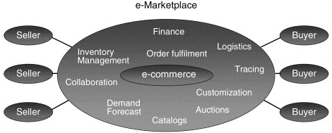

- These types of activities allow e-marketplaces to build their value proposition upon three fundamental elements. In order of rising complexity they are (1) increased market efficiencies, (2) increased supply chain efficiencies, and (3) new value creation.

- The intensified competition and the increased transparency of the Internet go hand in hand with the emergence of e-marketplaces and push prices closer to the theoretical equilibrium.

- Also supply chains have a vast potential for better efficiency. For the purpose of optimising business processes across supply chains, Supply Chain Management (SCM) has been studied and practised intensely in the 1990s.

- Successful e-marketplaces build on the same thoughts as they bring a standard for collaboration and interaction between companies. By providing users with good collaboration tools such as demand forecasting, inventory management and production planning, e-marketplaces help provide increased visibility across several tiers of the supply chain. Furthermore, because the way to collaborate is standardised, e-marketplaces also allow for a much more dynamic choice of sourcing partners.

- The foundation for innovative services creating new value is information. The vast amount of information about product offerings and transactions of the participating companies now available from one single source becomes more transparent. Building on that information base new value can be created by bringing more radical and transformational changes to the supply chain yielding efficiency at a level not at all possible before the emergence of e-marketplaces.

- Value can be created from new ideas having a fundamental impact on the business scope of both the e-marketplaces themselves and the participating companies.

- distinguish between two types of e-marketplaces: horizontal e-marketplaces and vertical e-marketplaces. The horizontal e-marketplaces are based on functions and/or products common across industries (i.e. the operating input), while the vertical e-marketplaces are those that are based on a specific industry tied together by the manufacturing input.

- The core value proposition of horizontal e-marketplaces is usually that of lower transaction costs in the purchasing process while a lower price is also often the result for buyers. However, because of the diversity of customers it is hard for horizontal e-marketplaces to introduce effective collaborative tools with an effect on overall supply chain efficiency. In contrast facilitation of collaboration is usually the core value proposition of vertical e-marketplaces as they are well positioned to cater for special needs, wants and customs attached to each industry.

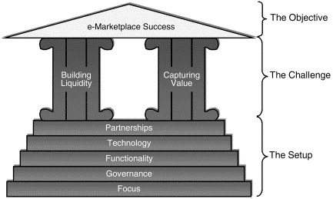

- First: create a powerful setup (thus creating a strong strategic position) and meet the challenge of building liquidity and capturing value.

- Second: marketplace is successful only if it is profitable.

- Third: the setup of an e-marketplace should be changed continuously as the environment of the e-marketplace changes and the e-marketplace grows and matures.

- Fourth: e-marketplaces must always keep in mind that decisions on how to capture value influence the building of liquidity – and the other way around.

Focus

Involves identifying what specific buyer and seller segments to target as well as deciding what type of products should be available on the e-marketplace.

Governance

It is in most cases advantageous for the e-marketplace to choose a neutral form of governance equally attractive to buyers and sellers.

Some of the benefits of a neutral form of governance are:

• A perception of fairness and the trust of trading participants:

– Making it easier to agree on standards for product specifications and collaboration functionality

– Making it easier to carry out regulatory tasks such as supplier qualification, evaluation of credit worthiness, resolution of disputes, etc.

• Fewer channel conflict issues:

– Leading to increased transparency

– Leading to better exploitation of potential market and supply chain efficiencies.

Functionality

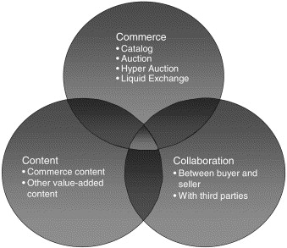

Technology

The major criteria for the technological platform is that it should be able to support the development of advanced market making tools (i.e. different catalogue structures and auction types), integrated procurement tools (e.g. searchable catalogues and administrative tools), and advanced collaboration tools.

Partnership

Choosing the right partners is key to being able to scale up quickly and to be able to offer participants on the e-marketplace a wide array of services within the domains of commerce, content, and collaboration.

Potential partners for an e-marketplace include investors, buyers in the chosen market space, sellers in the chosen market space, existing broker intermediaries, new infomediaries, content providers, IT vendors, and software developers. Partnering with key industry suppliers and buyers is especially important for vertical e-marketplaces, for which signing up a few big players early can often mean the difference between success and failure in consolidated industries.

Horizontal e-marketplaces are likely to struggle with delivery of industry specific functionality and content. Partnering with a vertical e-marketplace can circumvent this problem, as the service offering towards a particular industry can be extended.

Building Liquidity

The main service an e-marketplace provides is a centralised market space, and the more likely a buyer or seller is to make a satisfactory transaction using the e-marketplace, the more likely they are to join that e-marketplace instead of its rivals. Therefore, not only liquidity in terms of transaction volume, but also liquidity of information is needed in order for the e-marketplace to be attractive to buyers and sellers.

Building the transaction volume is more important than the number of members at the start. Therefore e-marketplaces should target key players who are likely to trade the most and get them to join early, rather than focusing on signing up most number of players. To speed up the adoption process e-marketplaces should actively help these key customers migrate transactions to the e-marketplace. Contracting with key buyers and sellers or perhaps offering equity in the e-marketplace in exchange for participation is a common way for e-marketplaces to get off the ground and secure initial liquidity

Capturing Value

In order for the e-marketplace to capture value it first needs to put together a value proposition that is compelling to its target customers – both buyers and sellers. Second, it needs to turn this value proposition into a steady income. The key to doing this lies in understanding the advantages and limitations of the various revenue sources available and turn these revenue sources into a complete revenue model that as accurately as possible reflects the value proposition as it is perceived by the various target customers.

Making the value proposition compelling

E-marketplaces create value for their participants through (1) increased market efficiency, (2) increased supply chain efficiency and (3) creation of new value. In order to make the value proposition compelling to both buyers and sellers it is however necessary for e-marketplace managers to have a detailed understanding of the benefits as buyers and sellers perceive them.

The fact that increased market efficiency often results in value transfer impacts the prospects for e-marketplaces to capture value. That is, it will be much easier to impose fees on the party that benefits from the market efficiencies that the e-marketplace creates than on the party that does not benefit.

This is important to keep in mind when deciding on what functionality to offer the e-marketplace participants. The e-marketplace should make sure to verify that it does not solely offer functionality that benefits only one party as this might deter the other party from participating.

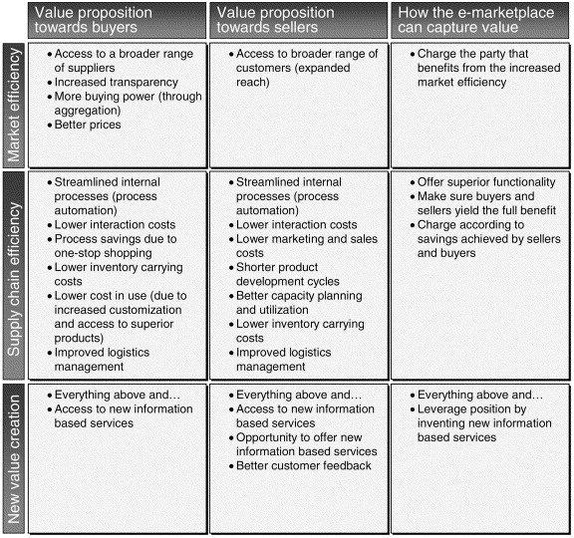

In order to make sure that buyers and sellers exploit the full potential of the functionality offered it might be a good strategy for the e-marketplace to offer advice (e.g. in the form of consulting services) on the optimal use of its services. Furthermore, offering consulting services on implementation issues is an additional potential revenue source for the e-marketplace.

Source of value, new value creation, represents a huge potential for powerful value propositions to e-marketplace participants as they per definition provide the participants with new value they cannot get anywhere else. For the same reason innovative services that create new value can be a very strong source of profit for the e-marketplace itself as well as a powerful differentiator. Furthermore, if the e-marketplace can leverage its aggregation of transaction information into developing new information-based services this can be a strong way to capture additional value.

Configuring the Revenue Model

While the revenue model of an e-marketplace can be based solely on a single fee type, it is most often preferable that the revenue model rests on a combination of fees. This ensures that the e-marketplace becomes less vulnerable to competition as well as allowing the e-marketplace to tie its revenue model more accurately to the value being created.

Central to the configuration of the revenue model is the value that the e-marketplace creates as perceived by the customer. This perception of value often differs significantly amongst different types of customers. Knowing the customer therefore is key to deciding upon an appropriate revenue model. It is preferable that the revenue model takes into account the different customer types and where possible uses prices that are tailored to specific customer segments.

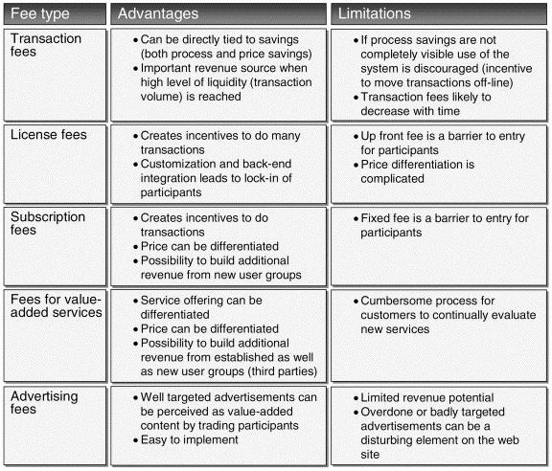

Reference

Brunn, P., Jensen, M. & Skovgaard, J. 2002, "e-Marketplaces:: Crafting A Winning Strategy", European Management Journal, vol. 20, no. 3, pp. 286-298.

1. Redefine competitive advantage. E‐commerce is changing the basis of competition. The economics and speed of conducting business are changing. Management of fixed costs and customer expectation has become critical for success. The Internet is transforming how people sell things in a host of industries. Executives must redefine their competitive advantages in terms of cost, differentiation, and marketing. For example, e‐commerce will continue to reduce the transaction costs of sellers and increase the penetration of the sellers’ messages into the market. On the other hand, it will be more difficult for sellers to differentiate their products, and consumers will be more easily able to compare prices and features from a number of sellers. In addition, e‐commerce has changed the rules of distribution. Compaq built the best retail‐distribution network in the computer industry in the 1990s but cannot compete with Dell’s “fast and light” direct sales approach enabled by the Internet technology (Browning and Reiss, 1999).

2. Rethink business strategy. It is very simple to set up a Web presence but quite difficult to create a Web‐based business model (Ghosh, 1998). Executives must generalize thinking beyond building a Web site to designing an architecture that will support company’s e‐commerce strategy. E‐commerce technologies make it cost‐effective and easy for customers to interact with a company and at the same time, reveal their purchase pattern and preference. Overall, executives must take a comprehensive look at how they can focus all investment behind a single winning strategy that makes it easy for customers to do business with them. For example, a company can leverage its brand name and the existing physical stores to serve its e‐commerce customers (e.g. toysrus.com), or offers customers assistance in the whole process of purchasing a product (e.g. edmunds.com) or commodity (plasticsnet.com).

3. Re‐examine traditional business and revenue models. Rayport and Sviokla (1995) describe participating in e‐commerce as competing in both the marketplace and the marketspace. Products and services exist as digital information in the marketspace and can be delivered through information‐based channels. Information itself is a source of value and presents opportunities to develop new relationships with customers at very low cost (e.g. FedEx and UPS). It also presents opportunities to create new services (i.e. new business and revenue models) and to improve internal efficiency (e.g. Boeing’s intranet). Executives must pay attention to how their companies create value in both the physical traditional business and the e‐commerce information world.

4. Re‐engineer the corporation and Web site. A Web site should not simply be used as a channel of providing marketing and company background information (i.e. brochureware). It should be a channel to collect customer information through interactions, transactions, and/or personalization. The most effective Web sites are also able to foster a feeling of community among customers (Armstrong and Hagel, 1996). To implement a customer‐centered e‐commerce model, a company needs to integrate its suppliers, back‐office functions, and front‐office functions in order to achieve the organizational flexibility necessary to move at Internet speed and to satisfy customer demand. In sum, a company must reengineer the customer‐facing business processes from the end‐customer’s point of view. The integration must be invisible because effective e‐commerce is a seamless, customer‐focused operation that works toward the highest level of customer satisfaction. Dell Computers’ build‐to‐order model has built stronger and deeper relationships with customers (Browning and Reiss, 1999).

5. Re‐invent customer service. The strategic and fundamental changes brought by the Internet are affecting every company’s relationship with its customers and the value propositions for many companies. Companies must take advantage of e‐commerce’s disruptive attributes and be able to build cost‐effective total experience and loyalty‐enhancing relationships with the most profitable customers. To achieve this goal, producers must create specific products that are imbued with the knowledge, requirements, and tastes of individual customers because in the Internet economy consumers become involved in the actual design process (Tapscott, 1999). Companies need to involve customers in the product development process through initiating technology‐facilitated dialogue, i.e. a willingness to give consumers access to the company and to view their actions and feedback as integral to developing and improving products (McKenna, 1995). In addition, companies must gather knowledge about their customers by building and controlling a comprehensive customer database, i.e. a digital asset made up of customer profiles and preferences. Amazon.com is able to redefine economies of scope by drawing on a single set of digital assets to provide value across many different and disparate markets to maximize customer value.

Lee, C. (2001), "An analytical framework for evaluating e‐commerce business models and strategies", Internet Research, Vol. 11 No. 4, pp. 349-359. <https://doi-org.dcu.idm.oclc.org/10.1108/10662240110402803>

**Overhead costs**

<https://cloud.google.com/pricing/list>

<https://aws.amazon.com/pricing/services/?nc1=h_ls>

<https://cloud.servecentric.com/pricing/?gclid=CjwKCAjw4pT1BRBUEiwAm5QuRxth20Rsmv4WTqevu2jBwRK-AqVUm_U76ZDk8LroiwQsUDrApL1jLxoCoWIQAvD_BwE>

**Considerations**

A fee should be charged monthly and both the vendor and the customer take charge of the shipment. Otherwise we would have to enter into a partnership with a courier company or form a side-business dedicated to shipping the products.

To attract businesses that do not know or do not trust e-commerce platforms, a free consulting service could be given to migrate their business to our platform or charge for the consulting service and we can register their product catalog, prices, etc. , on the platform